Inquiry Project Plan
Inquiry Title: | Get close to nature | Time Frame | 4 lessons | Inquiry Approach: | Place-based learning
Name: | Lingjin(Clarity) Liu | Subject(s): | Outdoor Education | Grade(s): | Grade 1-3

Inquiry Project Rationale & Overview
Why does this topic matter to students?
Farmer et al., (2007) stated that outdoor education activities that take children outside the classroom and help them to learn knowledge in a natural environment (as cited in Tas& Gulen, 2019). In my four lesson, our students will have a chance to get close to the nature, they will learn basic knowledge of the nature and the sign of Spring based on the nature environment, they will be outside to do some inquiry activities about investigating spring, and they learn knowledge of environment protection.
How does this project incorporate the inquiry cycle?
Teachers will leave some hints for students at the beginning of this lesson, and our students will develop new questions while doing outdoor investigation, teachers create a place for them to take outdoor education and they create connection of life, knowledge and the nature environment. Our students will discuss and share their feeling and signs of spring and then reflect to the basic knowledge of nature and environment protection.

Key Questions For Inquiry
Core Question | Supporting Questions
(1) What signs will you find of spring?  (2) Will this inquiry lesson be beneficial for students to develop basic knowledge about the nature?  (3) Do this lesson develop students’ curiosity about the nature?  (4) Will students learn how to communicate with others?  (5) Will students learn how to cooperate with classmates? | (1) What signs will you find of spring?  (2) Will this lesson be beneficial for students to develop basic knowledge about the nature?  (3) Will students learn how to communicate/cooperate with classmates?

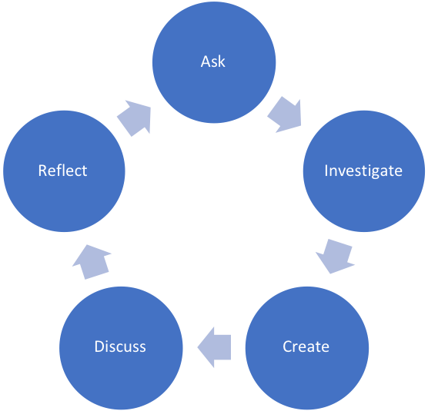

Inquiry Approach and Rationale
This lesson will give our students chances to learn knowledge of the nature and look for signs of spring. It will help students to connect their life and nature. When our students are looking for signs of spring in the park, they will get close to flowers, trees, bugs, grass and so on. While they are working with classmates, they will learn how to cooperate and communicate with others to improve their skill of communication and cooperation. At the last class of this lesson, our students will learn some knowledge of environment protection to teach them appreciate good environment and life they are living now.

Core Principles of Effective Teaching (Sharon Friesen)
Core Principle 1: Effective teaching practice begins with the thoughtful and intentional design of learning that engages students intellectually and academically.  *What aspects of the inquiry are the most challenging and meaningful for students? | Students can rise questions with the help of teachers, this class place students in the center, our students can investigate the nature with their classmates to develop their self-awareness and management skills.
Core Principle 2: The work that students are asked to undertake is worthy of their time and attention, is personally relevant, and deeply connected to the world in which they live.  *What makes this inquiry valuable, meaningful, and “alive” for the students and teachers? | Inquiry is beneficial for students to develop ability of thinking, developing new questions.
Core Principle 3: Assessment practices are clearly focused on improving student learning and guiding teaching decisions and actions.
*How do I define learning and success in this inquiry? How is learning expressed and articulated in peer, self and teacher assessments?
Core Principle 4: Teachers foster a variety of interdependent relationships in classrooms that promote learning and create a strong culture around learning.  *How do I connect students with each other, with experts in the field, with larger communities and nature, and across disciplines? | In this lesson, our students can cooperate with classmates to find signs of spring in the park to help them connect with each other, with nature. Based on the principles of new Science Curriculum Standard, students can connect with disciplines.
Core Principle 5: Teachers improve their practice in the company of peers.
*How do I reflect on the inquiry together, and/or collaborate with others?

BC Curriculum Core Competencies
Communication | Thinking | Personal & Social
-Students acquire, develop and transform ideas and information, and make connections with others to share their ideas | -Ability of developing questions  -Ability of critical thinking | - students can identify their identity in the world, both as individuals and as members of their community and society  -Building relationships

BC Curriculum Big Ideas (STUDENTS UNDERSTAND)
1. To observe the scenery of spring and feel the beauty of spring.
2. To help students learn the basic scientific knowledge related to the common things around.
3. Understand the process and methods of scientific inquiry, try to apply them to scientific inquiry activities

BC Curriculum Learning Standards
(STUDENTS DO) | (STUDENTS KNOW)
Learning Standards - Curricular Competencies | Learning Standards - Content
1.To applied basic scientific knowledge to daily life, gradually developing scientific behavior and living habits.  2. To communicate with classmates and increase our knowledge | 1. To cultivate students' environmental protection concepts and participation consciousness.  2. To develop students’ consciousness of nature protection

Indigenous Connections/ First Peoples Principles of Learning
How will I incorporate Indigenous knowledge and principles of learning?
The participants of my inquiry project are grade 1 to 3 students. I want to use those First Peoples Principles for learning which are “Learning involves patience and time.” “Learning involves recognizing that some knowledge is sacred and only shared with permission and/or in certain situations.”

Respectful Relations
How will I invite students of all backgrounds, interests and skills into the inquiry?

Firstly, this lesson is a seasonal lesson. It fits within different seasons’ features to design lesson content. It includes unknown things that could rise students’ interest. Secondly, students learn basic knowledge about nature, it is not difficult for them. Thirdly, students can improve their skills of communication, cooperation and discussion.

Project Overview
Time Estimate |  | Description of Teacher and Student Activities | Assessment Activities
Ask | 4 classes | -Brainstorm:  Teacher will ask question: 1. How does spring/summer/autumn/winter look like in you mind? 2. When will spring/summer/autumn/winter come in your mind? Students will discuss with group members and share their ideas about these questions.  -Storytelling:  Teacher will read four picture books about four seasons to show some signs of spring/summer/autumn/winter. Students will learn some vocabulary/signs of four seasons. | -Peer assessment: Group members will share their ideas with the entire classmates.  -Answer Questions  Students will answer these questions to be tested how they learned from these books.
Investigate | 4 classes | -A walking curriculum  Teacher will lead students to take a walk in the park.  -Investigate Outside  Divide students into groups find take pictures of signs of spring/summer/autumn/winter that they learn from the book or something which can present winter.
Create | 3 classes | Students try to draw what they saw in the park in different seasons with the help of teachers. | Pictures/photos
Discuss | 4 classes | -Taking Circle  Teacher will ask: 1. What did you find for spring/summer/autumn/winter?  2. Do you find any differences in four seasons?  Students will answer these questions with their own words.
Reflect | 4 classes | Journals  Teacher teach them to write a short journal about what they saw in the park in different seasons. | Journals

Materials
Picture books: The Thing About Spring by Daniel Kirk; And Then Comes Summer by Tom Brenner; Autumn Leaves by Ken Robbins; Winter Is Here by Kevin Henkes.
Phone or camera
Pencils
Paper
Talking circle

Organizational Strategies
1. Dividing Groups: students will choose a leader of their group and follow his/her leading.
2. Talking circle: students will sit on the grass in certain distance as a circle to share what they found in the park.
3. Teacher will make sure that students’ safety.

Proactive, Positive Classroom Learning Environment Strategies
Students have a good environment in the classroom to focus on the picture book reading, they will understand signs of spring deeply to help them look for those signs easily.

Extensions
1. Write poems.
2. Recommended picture books:
Spring: When Spring Comes by Kevin Henkes; Bunny’s First Spring by Lloyd Jones; It’s Spring by Linda Glaser
Summer: My Awesome Summer by Paul Meisel; Summer Walk by Virginia Snow; It’s Summer by Linda Glaser
Autumn: Leaves by David Ezra Stein; It’s Autumn by Linda Glaser
Winter: It’s Winter by Linda Glaser

Reflections (to be completed after Project Completion)
What did I learn about Inquiry Based Pedagogy?

It is a good teaching and leaning strategy for both teachers and students. It is beneficial for teachers to develop students’ passion and talent, and it could promote the motivation and engagement of students in and out the classroom. Inquiry-based pedagogy enables students to take ownership of their learning and to reach their goals.

What challenges and successes did I experience?
To be honest, it is hard for me to take this lesson, because most of my classmates are experienced teachers or have some experiences of teaching or designing teaching plans. Inquiry is total new field for me, so I take much time to learn it. Through this lesson, I learned the basic knowledge of inquiry, some inquiry related approaches, and benefits of using inquiry based approached which teaching and learning. It is good for my future learning and teaching.
What would I adapt for next time?
I think I should take more time to read more articles and some class examples about inquiry-based pedagogy.
What questions do I still have about Inquiry Based Pedagogy?
I’m wondering if I can apply inquiry-based pedagogy into different subjects? it takes me time and energy.

